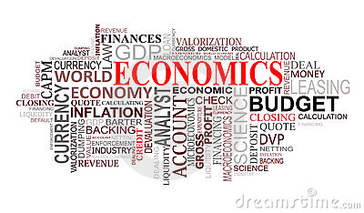
Mr. Breslin
Economics 12
2017 – 2018
Welcome Back!
Dear Parents/Guardians and Students,
Welcome back from your summer vacation! We hope you had a good summer and are looking forward to a great school year. In order to have the most rewarding experience, parent/guardian and student cooperation with classroom rules, expectations, and requirements are important. Keeping an open line of communication is essential; therefore, we can always be reached through email at:
KBreslin@cps.k12.ny.us
COURSE DESCRIPTION
Economics is a natural part of our daily lives, and this course is designed to help you understand how the economy operates by examining a variety of issues ranging from small businesses and money management to taxes and spending by the federal government. This course must be successfully completed in order to meet graduation requirements. It is crucial that you are prepared for class and complete all assignments.

CLASS MATERIALS:

- A 3-ring binder OR Spiral Notebook with folder
- Loose-leaf paper
- Pen/Pencil
- Highlighter

GRADING POLICY:
- Tests = 40%
- Quizzes = 20%
- Projects = 20%
- Homework = 10%
- Participation/Class work = 10%
*HOMEWORK POLICY:
Students are expected to complete all homework assignments and bring them to class ON TIME!! Homework assignments will be collected for a grade. Late assignments will not be accepted.

ACADEMIC HONESTY:
It is my expectation that all work completed and turned in will be your own. If you are caught cheating in any form, which includes but is not limited to: copying homework, plagiarizing research reports and giving or receiving answers on tests or quizzes you will receive a ZERO for that assignment or test and be subject to further disciplinary action.

ATTENDANCE POLICY:
- If you have an excused absence, it is your responsibility to get assignments and class work when you return to class.
- If absent the day of a test or quiz, the assessment must be made up within three days.
- If absent the day a project is due, the assignment is due the day you return.

FINAL EXAM EXEMPTION:
- Students maintain an 80 or higher test average will be exempt from the Final Exam in January
- On time daily attendance is required to be eligible for exemption from the Final Exam
Extra Help:
- Extra help takes place for Mr. Breslin: ____________________________________
Classroom Responsibilities:
- Students will raise their hand if they would like to speak.
- Students are to be respectful of one another.
- Students will come to class prepared and ON TIME.
- No cell phone use in class, unless authorized by the teacher.
  - Unauthorized use will result in 1 POINT off your QUARTERLY average for each infraction.

After reading through this syllabus, please sign and return the bottom portion of this page

Let’s have a great year!

_____________________________________________________________________________________
Economics Mr. Breslin

_________________________________________
Print Student Name

I have read this course syllabus and understand the expectations.

_______________________________ ________________________________
Student Signature Parent/Guardian Signature

_______________________ __________________
Date Date

Parent/Guardian email address and/or cell phone number (optional):

